APPLICATION
LICENSED ONLINE TRAINING

LICENSED ONLINE TRAINING - ID 503 Product Safety & Conformity Representative (PSCR) PERSONAL DETAILS Dates: 23 - 24 March 2022
Name of organization:

Address:

Phone:

ID VAT:

PARTICIPANT OF TRAINING
Name, Surname: Job title:

Phone:
e-mail:

IBAN (Bank Account):

Date of Birth:

mail:

PBaAseTdRonICaIbPinAdiTngIOapNpliFcaEtioEn, we will send you an invoice for the full price for the training. By paying the invoice, you will secure your participation at the training. By not paying the invoice, your binding application is considered irrelevant. In case of non-participation, it is possible to check out no
later than 5 working days before the training. The participation fee is not refundable, it is possible to send a substitute.

Bank transfer information
Bank: Tatra Banka a.s.
Text for the recipient: number of invoice
IBAN: SK39 1100 0000 0026 2153 5285 SWIFT: TATRSKBX
ID VAT: SK2020699527
In case of interest, please, contact us by e-mail at konferencie@ssk.sk or by phone on mobile 00421905 956 311

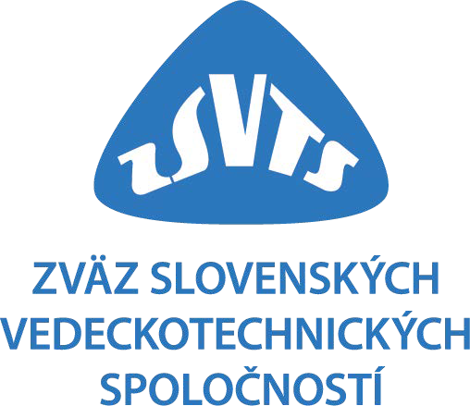

In ............................... date Signature / Stamp:

