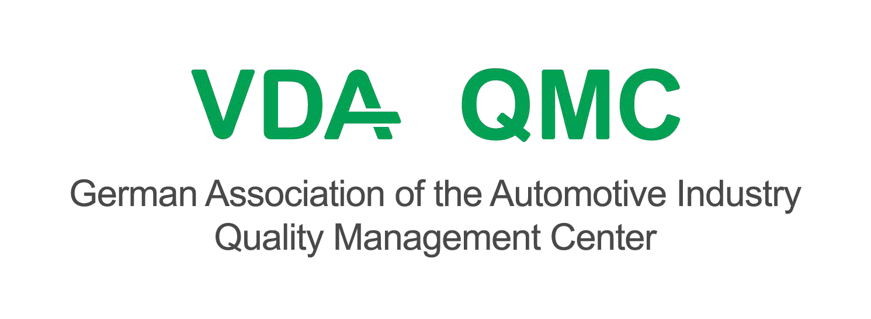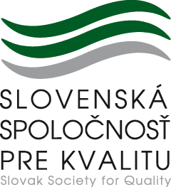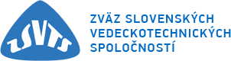

INVITATION TO EXAM
Qualification of VDA 6.3 Process Auditor

Dates | EXAM title | Target group
21st October 2022 | ID 353 Qualification  of VDA 6.3 Process Auditor | VDA 6.3 Process Auditor

Place of examination: Bratislava, Slovak Republic

Participation Fee:
Price without VAT | 440,00 €
VAT (20%) | 88,00 €
Price with VAT | 528,00 €

Based on a binding application, we will send you an invoice for the full price for the exam. By paying the invoice,you will secure your participation at the exam. By not paying the invoice, your binding application is considered irrelevant. In case of non-participation, it is possible to check out no later than 5 working days before the exam. The participation fee is not refundable, it is possible to send a substitute.

Bank transfer information: bank: Tatra Banka a. s.
IBAN: SK39 1100 0000 0026 2153 5285 SWIFT: TATRSKBX

Text for the recipient: number of invoice ID VAT: SK2020699527

Application: In case of interest, please, contact us by e-mail at trainings@ssk.sk or by phone on mobile 00421905 956 311

Refreshments: During the exam, refreshments are provided for participants.

Target group
The exam is intended for employees whose task is to ensure and perform internal (within their own organization) or external (in the supply chain) process audits. It is also suitable for external auditors appointed as third party audit providers.

Guarantor/Organizer:
Slovak Society for Quality, Šoltésovej 14, 811 08 Bratislava, Slovakia

Slovak Society for Quality, Šoltésovej 14, 811 08 Bratislava, Slovakia

Test procedure and procedure
The exam consists of a written and an oral part. The written part contains 40 questions that need to be answered within 60 minutes. The oral part lasts 20 minutes and is performed by two examiners. Upon successful completion ofboth parts of the exam, the participant will receive an auditor's card and a certificate, which is registered in the VDA QMC and SSK databases.

The exam starts in the morning at 8.00 am, on a specific day and the course is as follows:
- welcome and check of personal documents (please bring your identity card or passport)
- getting acquainted with the course of the exam, answering general questions
- 3rd oral and written exam (length of breaks and delays between individual parts of the exam may vary, lunch break is between 12.00 - 13.00)
Before entering the examination, the applicant for the examination must document the following details for the inspection:
  - certificate of completion of the VDA 6.3 process auditor training (edition 2016, ID 315),
  - at least 5 years of experience, of which at least 2 years in quality assurance,
  - Proof of 3-day auditor qualification based on DIN EN ISO 19011 (IATF internal auditor according to ISO 9001 and ISO 14001)
  - 2-day Core Tools training, namely:
    - either Automotive Core Tools for Process and System Auditors (ID 417)
    - or at least 2 days of unlicensed training and then complete the Online Quiz.

Written exam
In the written part of the exam, the candidate demonstrates a general overview. The exam consists of 40 questions. There are 4 possible answers to each question. There is always only one correct. This is a choice exercise. For each correct answer, the candidate receives one point (maximum number of points is 40). The candidate willpass the written part of the exam if he / she correctly answers at least 70% of all questions (minimum 27 questions). It does not matter which questions the candidate answers correctly - the only criterion is the percentage of success. Candidates who answer less than 70% of the questions must repeat the written part of the test. It is not allowed to useany aids during the test. The written part of the exam lasts 60 minutes.

Oral exam: case studies
In the oral exam, the candidate demonstrates an ability to apply their knowledge in practice using appropriate examples.

In a limited time of 20 minutes, he applies process-oriented analysis and process audit procedures to specific examples (case studies), including:
- Process analysis ("turtle" diagram, inputs - outputs, etc.), human resources, material resources, workload and efficiency
- Identification of risks related to the case and process
- Relevant requirements resulting from the VDA questionnaire 6.3
- Evaluation of findings (case study)

The learner will, among other things, focus on the evaluation of presentation skills and the participant's performance. During the preparation, for which the candidate has 30 minutes, it is allowed to use materials obtained during the VDA course (including VDA 6.3).

Duration: 30 minutes for preparation and about 20 minutes for presentation

The candidate will find out the result of the oral exam together with the result of the written exam after all registered candidates have passed the exam.

Downtime and test time
Despite careful preparation, it cannot be ruled out that candidates will wait for a certain period of time before being admitted to the examination. However, we will do our best to keep downtime as short as possible. The exact time of the exam will be known to the candidate upon arrival. According to the assigned number, everyone knows whether to start the oral or written exam. After passing both parts of the exam, the candidate will receive the results.

Sending the auditor's certificate and certificate
The results of the examination will be sent to the address given by the candidate upon the arrival, unless otherwise agreed.

Issuance of certificate and auditor's license
After passing the exam, the candidate will receive an auditor's certificate and a certificate by mail. No additional fees are charged for this operation. In order to be able to issue an auditor's card, the applicant must send his photograph in passport format in electronic form, by e-mail to: vda@ssk.sk.

Literature

Exam preparation materials
- Materials from the VDA course, a
- Current issue of VDA 6.3

Professional guarantor:
Guarantor/Organizer: Contact:
E-mail:

certified VDA QMC auditors

Slovak Society for Quality, Šoltésovej 14, 811 08 Bratislava, Slovakia Mgr. Miroslava Mrázová
trainings@ssk.sk

A P P L I C A T I O N
ID 353 Qualification of VDA 6.3 Process Auditor

Dates of Examination:

CONTACT INFORMATION

Organization: Address: Phone:
e-mail:
ID VAT:
IBAN:

PARTICIPANT

Title, name, surname:

Job title: e-mail:
Phone:

PARTICIPATION FEE:

PRICE:
Price without VAT | 440,00 €
VAT (20%) | 88,00 €
Price with VAT | 528,00 €

The fee includes the cost of providing refreshments, examiners and exam materials. Based on the binding application, you will be issued an invoice for the full amount for the exam. By paying the invoice, you will secure your participation in the exam. By not paying the invoice, your binding application is considered irrelevant.

Bank transfer information: bank: Tatra Banka a. s.
IBAN: SK39 1100 0000 0026 2153 5285 SWIFT: TATRSKBX

Text for the recipient: number of invoice ID VAT: SK2020699527

Please send the binding application by e-mail (scan) to the address trainings@ssk.sk.

In ............................... Date stamp and signature:

